**21 Dec 2018** **The Weekly Bulletin of Rotary Club of Kathmandu Mid-Town** **bc-13.12/018**

|  |
| --- |
| C:\Users\Public\Documents\RIP T1819_EN.png |

District: 3292 Web:www.rotarymidtown.org.np Club Id: 26776

**DECEMBER IS DISEASE PREVENTION AND TREATMENT** **MONTH**

Rotary is dedicated to six areas of focus to build international relationships, improve lives, and create a better world. All global grant activities are required to align with the goals of an area of focus.

Disease prevention and treatment is one of the six areas of focus.

For disease prevention and treatment, the goals are:

1. Improve the capacity of local health care professionals

2. Promote disease prevention programs, with the goal of limiting the spread of communicable diseases and reducing the incidences of non-communicable diseases and their complications

3. Enhance local communities’ health infrastructure

4. Educate and mobilize communities to help prevent the spread of major diseases

5. Prevent physical disability resulting from disease or injury

6. Support studies for career-minded professionals related to disease prevention and treatment

7 Dec 018 Friday

**Club Assembly** (2nd) **: Club Meeting # 1467**

AG Bijaya Mallapaty conducted the Club Assembly;

Presentations during the club assembly:

PP Walter Diller on club administration, Rtn Shyam R Thapalia on membership development,

PP William Ma on public relations, PP Paras JB Rana on service projects, Rtn Isabella Khadka on TRF and Rtn Rabindra Shrestha on youth service on behalf of PP Chandra Lekha Tuladhar.

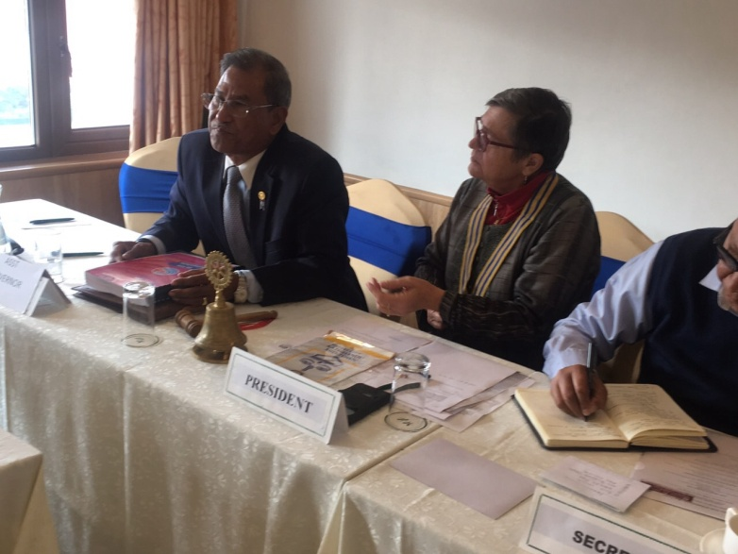 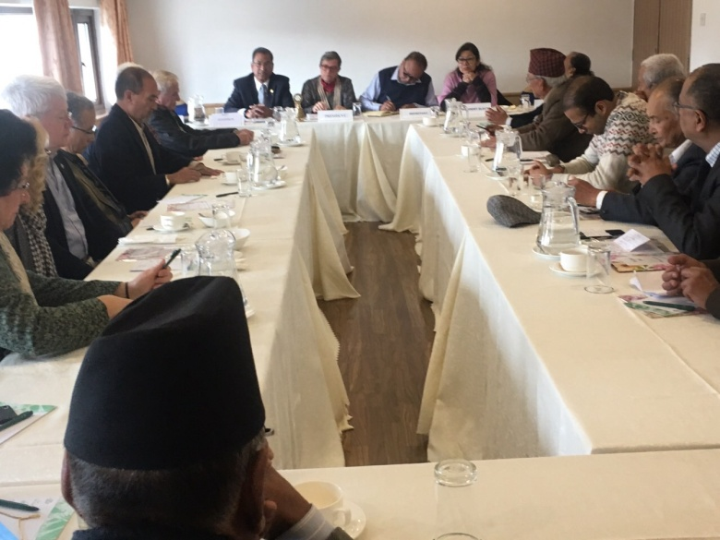

*Photo courtesy: Rtn Shyam R Thapalia*

12 Dec 018 Wednesday

**District Governor’s Official Visit : Club Meeting # 1468**

District Governor Chintamani Bhattarai along with District Secretary Rajendra Shakya had a special meeting with President Jo and Secretary PP Arun before joining in another special meeting of the Club organized for Club’s presentations as well as for listening to him.

Various Committee Chairs gave presentations on their respective fields:

PP Walter Diller on club administration, Rtn Shyam R Thapalia on membership development,

PP William Ma on public relations, PP Paras JB Rana on service projects, Rtn Isabella Khadka on TRF and Rtn Rabindra Shrestha on youth service on behalf of PP Chandra Lekha Tuladhar.

DG Chintamani Bhattarai thanked the Chairs for their presentations and provided specific comments on areas where improvement is called for.

**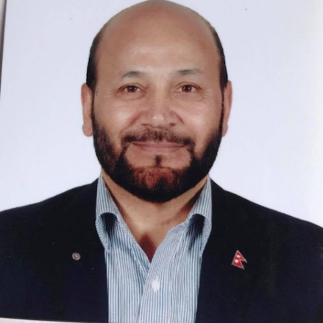** 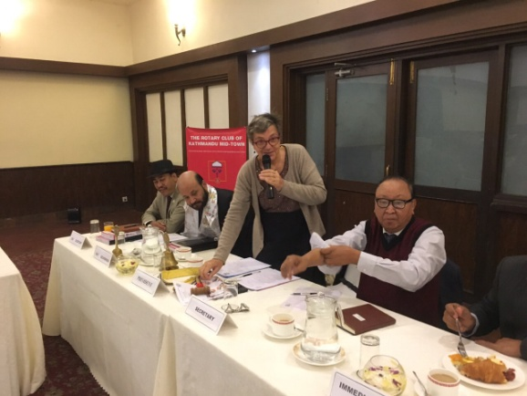 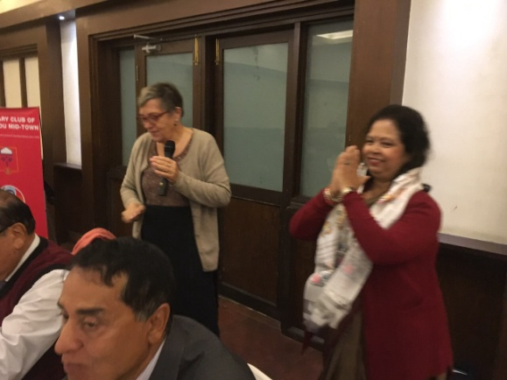

*Photo courtesy: Rtn Shyam R Thapalia*

**Weekly Meeting on Friday, 21 Dec 2018**

Our guest speaker will be our Mid-Towner Dale Mole.

He will be talking on “The message Christmas is giving to all of us”. May be we will have to celebrate

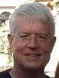

Christmas in a different way after listening to him!

Dale is CEO of Scheer Memorial Adventist Hospital in Banepa which is focused on holistic

medicine, and on physical, mental, and spiritual well-being.

**Rotary Culinary Get Together:**

Couple of like minded friends of the Club made it on Saturday afternoon. They visited together Kwancha Newari Khajaghar, Velachhen, Lalitpur to enjoy fellowship as well as tasting a variety of Newari foods/delicacies.

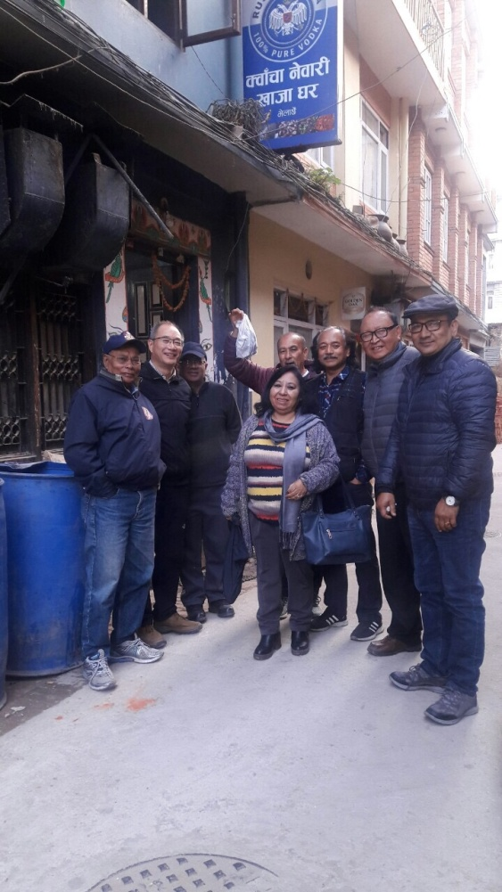 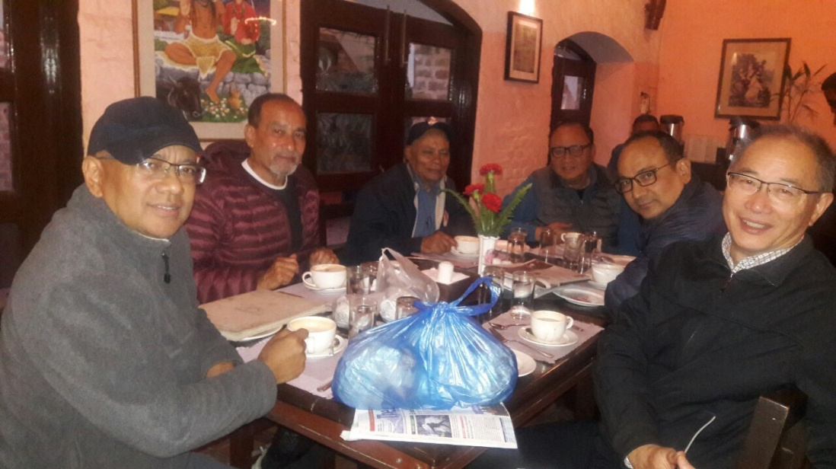

*Photo courtesy: Rtn Arun M Sherchan*

**Rotary International Convention, Hamburg:**

REGISTRATION FEES: ONLINE, MAIL, FAX

**Important deadlines:**

**15 December 2018:** Last day for early-registration discount

**31 March 2019:** Last day for preregistration discount

**5 June 2019:** Last day for online registration

28 June - 15 Dec 2018 16 Dec 2018 - 31 Mar 2019 1 Apr - 5 Jun 2019

Rotarian US$ 395 US$ 495 US$ 595

Rotaractor US$ 120 US$ 170 US$ 220

Interactor US$ 20 US$ 30 US$ 40

*Source: Rotary.org*

**District Programs:**

**The Rotary Foundation Seminar on** 22 Dec 2018 (Saturday) at Hotel Yak & Yeti

**A THOUGHT FOR TODAY:**

**“The weakest living creature, by concentrating his powers on a single object, can accomplish something. The strongest, by dispensing his over many, may fail to accomplish anything. The drop, by continually falling, bores its passage through the hardest rock. The hasty torrent rushes over it with hideous uproar, and leaves no trace behind.”**  Thomas Carlyle

*Courtesy: Rtn Dr Isabella Khadka*

On Lighter Side:

A married couple went to the hospital to have their baby delivered. Upon their arrival, the doctor said that the hospital was testing an amazing new high-tech machine that would transfer a portion of the mother's labour pain to the baby's father. He asked if they were willing to try it out.

Both said they were very much in favour of it. The doctor set the pain transfer to 10 percent for starters, explaining that even 10 percent was probably more pain than the father had ever experienced before. But as the labour progressed, the husband felt fine and asked the doctor to go ahead and kick it up a notch. The doctor then adjusted the machine to 20 percent pain transfer. The husband was still feeling fine. The doctor then checked the husband's blood pressure and was amazed at how well he was doing. At this point they decided to try for 50 percent. The husband continued to feel quite well.

Since the pain transfer was obviously helping the wife considerably, the husband encouraged the doctor to transfer all the pain to him. The wife delivered a healthy baby with virtually no pain, and the husband had experienced none. She and her husband were ecstatic.

When they got home they found the next door neighbour pained and dead on the courtyard.

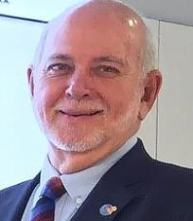

If you want to build a better world, don’t begin by planning projects or assigning tasks.

Begin with inspiration.

Begin by awakening the souls in your Rotarians the longing for a better world - and the

knowledge, deep and true, that *they* can create it.

**RI President Barry Rassin**

Please send information on club activities, progress reviews on service projects, relevant photos etc to:

BC Editor: RR Shrestha email: rryesrr@gmail.com

## 21 Dec 2018 The Weekly Bulletin of Rotary Club of Kathmandu Mid-Town bc-13.12/018

**Wishing you all a Merry Christmas and a Happy New Year 2019**

Double Click & Open ⇩



